MULTI SITE ALIASES

Vikash Raaj

Contents

Disadvantages of Default Feature 3

Advantages of Multi Site Aliases 3

Installation 3

Sitecore package 3

Physical File Package 3

Setting Up Site Specific Aliases Folder 3

Site Settings 3

How to Use the Plugin 4

Adding New Aliases 5

How it Looks Under Aliases Folder. 6

Supported URL 6

Source Code 6

Supported Sitecore Versions 6

Support 6

# Disadvantages of Default Feature

* Not supportive for Mutli Site, Multi Lingual site to maintain different Aliases
* Site A Aliases, would be used by Site B which is not an expected behavior.

# Advantages of Multi Site Aliases

* Easy to Configure
* Easy to share between sites
* Aliases of Site A won’t be used by Site B until configured as same source for Both.

# Installation

## Sitecore package

There are no Sitecore Package used.

## Physical File Package

Unzip and copy paste the folders to the Instance folder, this will update 1 xml file which is used to load the Aliases popup and rest are the custom built code and config.

# Setting Up Site Specific Aliases Folder

## Site Settings

We need to add a property to the site as below where we need to use the Aliases. Sites which are not added with this property will not use the Aliases Feature.

SiteLevelAliases = “{5F2AB023-80DA-437E-B9C6-53B3A5FA9749}” 🡨Guid of a folder under Aliases

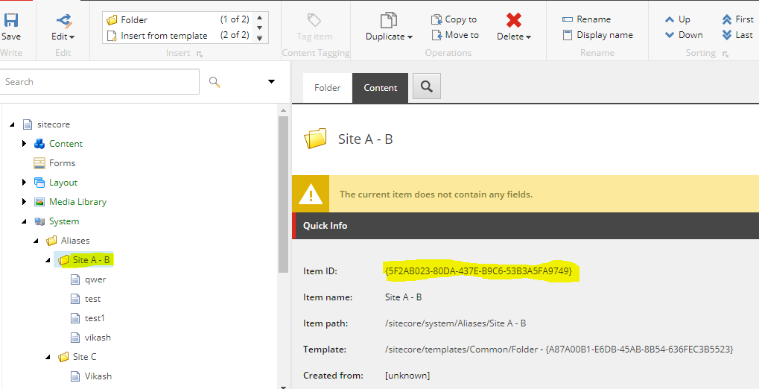

# How to Use the Plugin

Once installed and configured on required sites, we can use the feature as same as the normal aliases mode. Click on the item and click on the Aliases under presentation menu. You can see the window like below.

For Demo we have done the configuration to User Same folder for Site A , Site B and different folder for Site C.

On Popup, you can see the same auto grouped out for user to see clearly how the sites are classified.

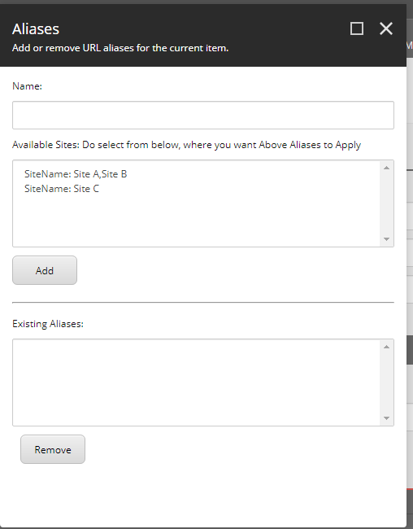

## Adding New Aliases

Type the Aliases name and select the required sites to include the Aliases. On click of Add, it gets added and update the Existing Aliases automatically.

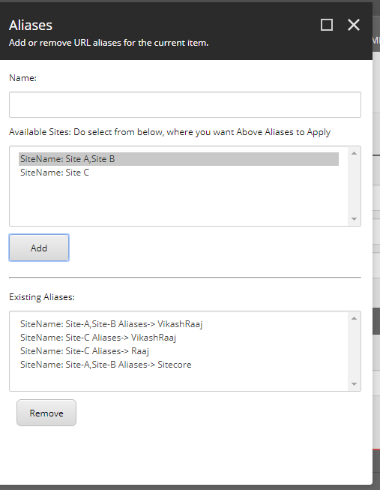

### How it Looks Under Aliases Folder.

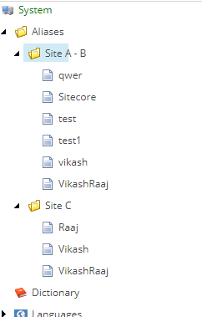

# Supported URL

We do support all the url patterns supported by default feature such as content, media

Aliases

Aliases\Aliases1

Aliases\Aliases1\Aiases2

# Source Code

Source Code is placed in github.com on <https://github.com/vikashinchennai/MultiSiteAliases>

# Supported Sitecore Versions

Currently the Code is built to support Sitecore 9.1 Update 1 version, but the user who needs to use in different version has to change the project version and build and then deploy to their Instance.

# Support

Please do reach out to me for any support on the plugin is required, ready to help out.